**1WRO Future Engineers - Engineering Journal**

Team name: Student Engineers

Team members: Jahmil Camacho, Angel Arocho

Age Group: 16-17

Project Title: Autonomous Car

Season: WRO 2025

Vehicle Name: CDC-07

**Table of Contents**

a. Initial Research

b. Strategy and Design Planning

c. Mechanical Design

d. Electronics and Sensors

e. Team Collaboration

f. Challenges and Solutions

g. Daily Engineering Report Entries

h. Possible vehicle improvements

i. Vehicle and team Images

**Objective:**

Develop and program an autonomous LEGO-based car that completes laps around a predefined track as quickly and accurately as possible.

Key Rules from WRO 2025 Guide:

Robot must be fully autonomous after starting.

The robot must complete laps around a closed circuit in under 3 minutes.

Speed and control are both important – penalties are given moving obstacles in the track.

**Initial Research**

**What We Investigated:**

* Racing line techniques and cornering dynamics.
* Drivetrain efficiency (2WD vs 4WD).
* Vehicle size and weight efficiency.
* LEGO-compatible sensor placement for optimal detection.
* Components for the chassis of the vehicle.

**Sources:**

* Previous WRO Future Engineers finals videos.
* LEGO forums and GitHub for sample code.
* YouTube (e.g., Roboriseit, TechBrick tutorials).

**Strategy and Design Planning**

**Main Design Goals:**

* Maximize turning precision.
* Smooth acceleration and steady speed control.
* Minimize margin of error for sensor detection.
* Consistent lap times with low variance.

**Sketches:**

**Lap Optimization Ideas:**

* Interior wall detection for tight turning
* Sensor feedback loops for steering adjustments.
* Color detection for track awareness.

**Mechanical Design**

**Chassis Design:**

* Custom low-profile LEGO chassis for low center of gravity.
* Rear-wheel drive with large wheels for torque.
* Front steering rack for precise movements.
* Front Smaller wheels for precision.

**Motors:**

* 1x Medium Blue Servo Motor (54696 / 79818) in the front for vehicle steering.
* 1x Medium Azure SPIKE Primer Motor (54675 / 99085) in the rear for vehicle movement.

**Key Innovations:**

* Changeable LEGO sensor mount for front and rear.
* Lightweight LEGO Technic framework.
* Swappable wheel sets for testing grip vs speed

**Electronics and Sensors**

**Vehicle power source:**

* 1x LEGO Spike V3 Large Hub

**Sensors Used:**

* 1x LEGO Color Sensors (color guide)
* 3-4x LEGO Ultrasonic Sensor (edge detection)

**Sensor Placement Strategy:**

* Color sensors in the front facing forward for obstacle detection for the challenge round.
* Ultrasonic Sensors facing every direction for full 360 detection.

**Team Collaboration**

|  |  |  |
| --- | --- | --- |
| **Member** | **Role** | **Key Contribution** |
| Jahmil | Designer, Analyst | Vehicle Design |
| Angel | Coding, Tester | Vehicle program |

**Challenges and Solutions**

**Problem 1:** Robot skidded out on sharp corners.  
**Fix:** Reduced speed at corners.

**Problem 2:** Wall detection would happen 50/50.  
**Fix:** Adjusted ultrasonic sensor position for better detection.

**Problem 3:** Vehicle stability was poor and would un align easily.  
**Fix:** Added support for wheels and front steering rack and larger wheels.

**Daily Engineering Report Entries:**

Date: 16/09/24

We started to think about how we were going to design the vehicle for it to be inside of the set size rules. We also started looking for inspiration on the internet from older WRO winners and participants.

Date: 17/09/24 – 19/09/24

The team decided to split tasks amongst each other to make the process quicker and easier. We decided on our first model for the vehicle and started to build. The idea consisted of making the vehicle as compact as possible so it would take as little space on the track for more margin of error without too many repercussions.

Date: 24/09/24

We did a test program to verify the stability, speed and weight distribution of the vehicle. The program was just to start the rear servo motor and observe the vehicle closely. After the test we noticed it was too heavy, we had to distribute for weight forward and backwards because the center was too heavy, the slightest nudge would tip him over.

Date: 25/09/24

The vehicle was elongated and most of the weight was delivered to the rear. We decided to add a second wheel to the rear for more traction and for it to be steadier. This resolved most of the problems, so we decided to start working on the program.

Date: 26/09/24 – 30/09/24

We had to learn how to work with the Lego word blocks. Angel made a test program to test the front steering rack, and we noticed that once the servo rotated the gear 2 ½ times the gear would slip of the rack. That was a problem that we had to fix as soon as possible for us to continue with the programming portion of the objective.

Date: 03/10/24

We found a solution to our problem we added a secondary gear to the steering shaft so that once the rack skips the first gear it would jump to the second gear and then fully turn.

Date: 07/10/24 – 10/10/24

We hit another roadblock which was that the front wheels didn’t have enough space to fully turn limiting our turning radius by about 1- 1 ¼ rotations because of the ultrasonic sensors in the sides of the vehicle. The vehicle was extended forward to avoid the wheels scraping or stopping from the sensors. After extending the steering was more precise and was efficient.

Date: 15/10/24 – 25/10/24

Angel did various programs to test and try and make the car do a single lap. The vehicle design still was faulty and did not allow him to do many things he wanted to do. None the less he worked with what we had and managed to figure out a lot of new things we could use inside the word blocks program like the advanced setting for more precise commands and instructions.

Date: 28/10/24 – 31/10/24

Major design changes were made I removed one of the rear wheels for it to be less heavy in the rear. I added a gear ratio for the rear motor for it to produce more torque. Also, I added more support to the wheels to get rid of wobbling due to thinner wheels. After all these changes the vehicle was a lot nimbler, and the gear ratio helped a lot with it going too fast and slipping.

Date: 02/11/24

Angel got back to programing and started working with a program that would detect the outside walls back up once it detected the wall and then turned 90 degrees either to the left or right depending on the orientation.

Date: 07/11/24

Angel had the final product of the program he was working on, but we noticed a lot of flaws right away. One of the flaws being that the Lego sensors sensitivity and range are very limited so by the time the camara detects the wall the vehicle would hit the wall and then execute the code. The second flaw is that it depended a lot on the robot always positioning itself perfectly straight towards the wall each time it would turn.

Date: 11/11/24 – 15/11/24

We tried to fix or find ways around that obstacle but no luck. Angel thought about using the internal gyroscope the spike has but we would have to do a lot of research to begin to use it. We ultimately decided we would use the gyroscope later on and opted on trying to fix the original program.

Date: 03/12/24

I decided to move one of the color sensors we had in the rear and move it forward and facing down because I had an idea for a better way to know where in the track the vehicle was.

Date: 06/12/24

Angel and I researched how to use the gyroscope to implement it somehow in the program to help the vehicle maintain a solid racing line and not divert so much.

Date: 10/01/25

We could not find a way to implement the gyroscope yet neither have we found a way to fix our issue. None the less we still brainstormed ideas, and we had a lot of good ideas that we worked on implementing.

Date: 13/02/25

Due to one of our members competing in Skills USA electronics technology competition due to him not being available because of practices we have not had time to dedicate time to the vehicle.

Date: 27/02/25 – 06/03/25

Angel got to work on a whole new program using the down facing sensor. He noticed that the test mat had 2 lines on each corner, one being blue and the other being orange. Using the sensor his plan is to make the sensor detect one of those colors and then durn 90 degrees in the direction it had to go. He ran into one problem the sensors would not detect orange only blue that was a big issue.

Date: 11/03/25

We found a way to use just the color blue for the program, but the sensor had a hard time detecting the blue for some reason we could not figure out.

Date: 13/03/25

Angel figured out the problem the vehicle was going too fast so he decided to lower the speed by 15% and that started to work but it would only read the blue 70% of the time now.

Date: 17/03/25

We ran into another problem the vehicle had a hard time following the racing line and keep diverting itself after ½ a lap. We observed that it was because the front wheels were wobbling making it un align quickly.

Date 18/03/25

I tried fixing our instability problem, but I could not find a way to fix it, so I decided to try and add as much support as possible without messing with the turning angle and that worked for the most part removing most of the wobbling but not completely.

Date: 24/03/25 – 28/03/25

We were stuck working on the program the whole week we modified and changed the code several times and nothing worked after various attempts we opted for the one that gave the best results, but it was still not great, but we had to keep it for the upcoming practice match.

Date: 05/04/25 (practice match)

The first round the programs failed horribly due to the car never straightening out. Second round we did some fixes on the spot and the programs stared to work a lot better we got about 3/4 around the course. The final round we made a super big change in the program that worked great, and the vehicle did 2 ½ laps around the course which was a new record for us and a breakthrough for us.

Date: 10/04/25 – 17/04/25

Angel has worked on perfecting the program we had so it could do the 3 laps perfectly and he’s also trying to implement the gyroscope again into the program because the vehicle keeps slightly diverting itself from its driving line and slowly after each lap getting closer to the inner wall.

Date: 28/04/25-30/04/25

We tried making some minor design changes because the vehicle was misaligning too much but after all the changes it didn’t help, we decided to try and add support to the original model of the vehicle. We also worked on perfecting our program making sure that there was little to no margin of error, but it has been difficult.

Date: 03/05/25 – 04/05/25 (competition day)

We where extremely nervous the first day, but we decided to keep calm and do our best. First round we only scored a single point but our opponent scored 0 so we where fine. Second round we noticed just how unprepared our opponents where when we scored 18 and they scored 0 again. Third round and we scored 13 while they scored another 0 because their robots steering was not programmed correctly then the challenge round came around and we didn’t prepare for it to well so we scored 0 but the opponent also scored 0 so its ok. At the end after adding the match scoring and the scoring for the documentation we won 51 to 14 and also won the medal for best engineering journal.

Date: 13/05/25

We noticed some of our biggest problems weren’t fully fixed so we started brainstorming ideas on how to fix or upgrade the robot and its code.

Date: 16/05/25

After a couple of days of thinking we decided to slightly modify the vehicle by giving it thicker wheels for better grip making the steering better and we relocated some of the sensors.

Date: 21/05/25

We finished the modifications and noticed a big increase in consistency, the bigger wheels made the vehicle way more stable, but we noticed it was noticeably slower.

Date: 22/05/25

I started to tweak with the gear ratios and then found a ratio that was fast yet still controllable and could still produce a good amount of torque for the vehicle.

Date: 02/06/25 – Date: 06/06/25

Angel started to really work on fine tuning the code and noticed a lot of unnecessary variables with he removed and decided to re define for better optimization.

Date: 09/06/25

Summer break started so we decided to take a break from the vehicle and continue when class started, but while on break we still were thinking on things we can do to the vehicle so when we came back from break already knew what we were going to do. We also had to take a break since I had a SkillsUSA competition in Atlanta that I had to attend.

Date: 18/08/25

School started back up and we immediately started working on the vehicle. Angel got to work perfectioning the code while I gave him some of my ideas and helped trouble shoot some problems.

Date: 21/08/25

We ran into a big problem we noticed our sensor combination wasn’t going to cut it anymore. So, I consulted it with Angel, and we decided to switch to 3 ultra sonic sensors and a single color sensor. This in theory is going to optimize and better the vehicle.

Date: 25/08/25

After the modifications to the vehicle we had to start with the sensor program from scratch again. We took the whole day measuring so we can set the perimeter for the sensors. After the measurements where taken we wrote them down to later on add them to the program.

Date: 29/08/25

We went to techno invertors for our first official practice with them and they also provided us with some part we needed to finish the mechanical side of the vehicle. We also decided to play around with the sensor a little bit since we had access to different types of sensors.

Date: 01/09/25 – 05/09/25

During this week we focused completely on the code and made a lot of advances and adjustments for it we noticed a lot of things that needed to be worked on, and we decided to tackle them separately instead of all together like we used to, and it worked way better, and we got better results.

Date: 08/09/25 – 12/09/25

The vehicle is basically done we put it through various tests and worked out some tweaks here and there but he’s almost ready for his big day.

Date: 01/10/25 – 07/10/25

This final week we made sure everything on the vehicle was in optimal condition and we also made sure the GitHub was perfect. We made sure we left as little room for error so the judges would give us a flawless score now we just have to pray that it’s enough to at least place in the top 5.

**Possible vehicle improvements:**

Some improvements we noticed that could be made to the vehicle will be listed here.

* 1. Shorter wheelbase:

Our vehicle is too long and most of the weight is near the rear making us lose a little traction on the front of the vehicle when turning. This can be fixed by shortening the length of the car in the front or bringing more weight to the front of the vehicle.

* 1. Different steering mechanism:

The vehicles steering is difficult to be precise with due to it being performed by a small rail that is turned by one of the servo motors. One fix is maybe using a bigger rail piece with a bigger gear for more precise and possible more turning angle.

* 1. Sensor placement:

The vehicle has 4 sensors 2 color sensors placed in the front of the vehicle, one facing forward and one facing down and 2 ultrasonic sensors to each side of the vehicle. I would suggest possibly placing one of the front sensors to the rear to determine if an obstacle is behind the vehicle.

**Vehicle and team Images:**

CDC Model 01:

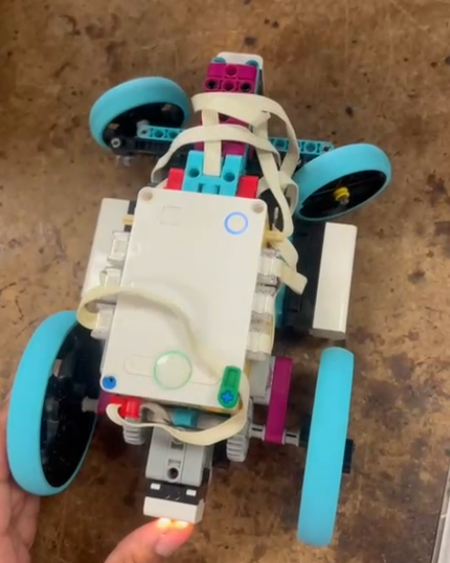

CDC Model 02:

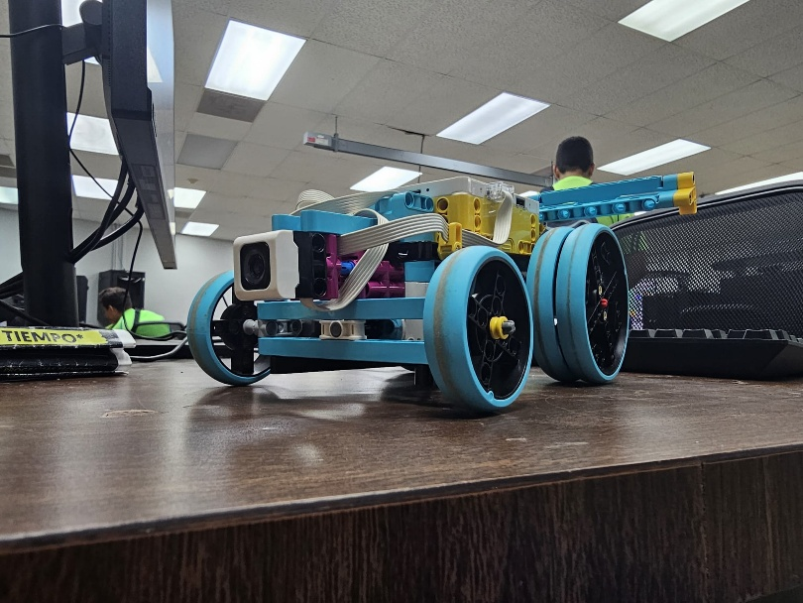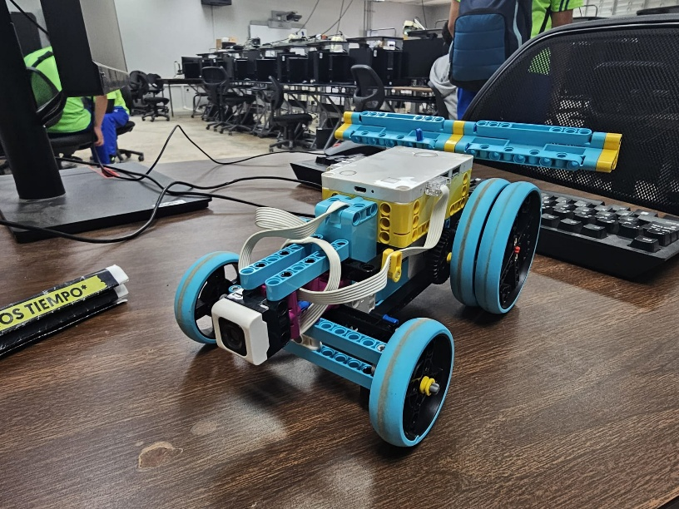

CDC Model 03:

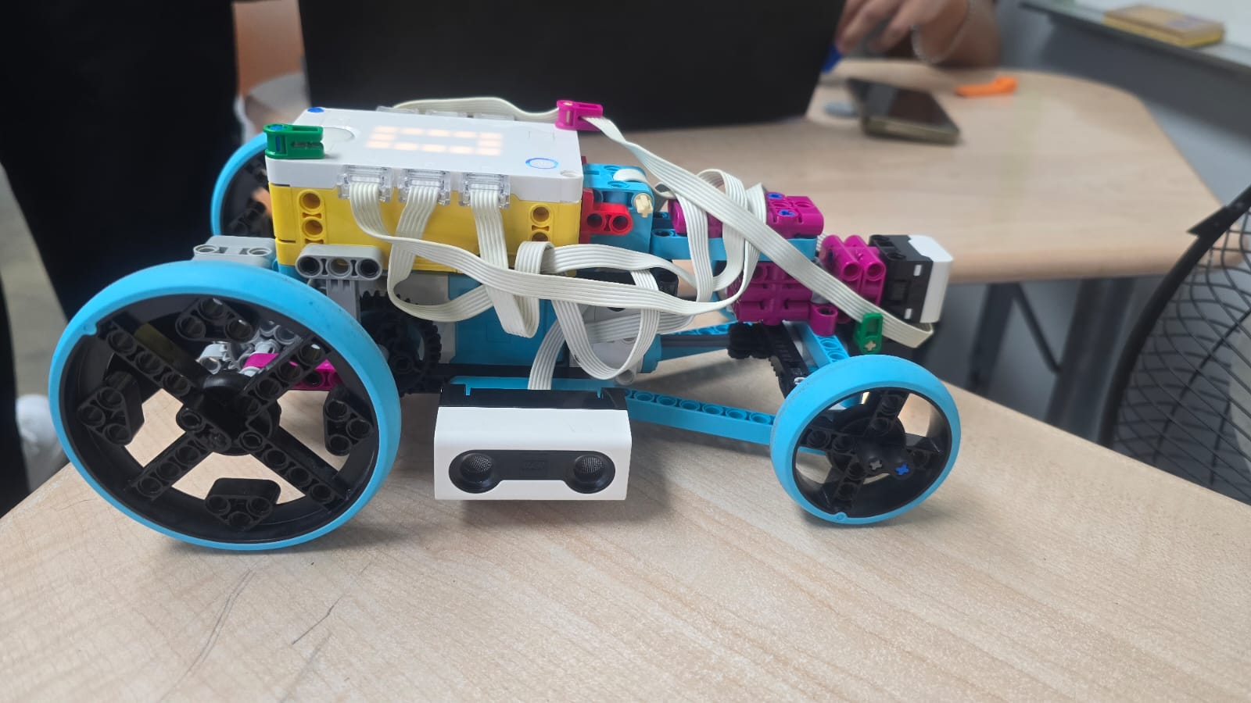

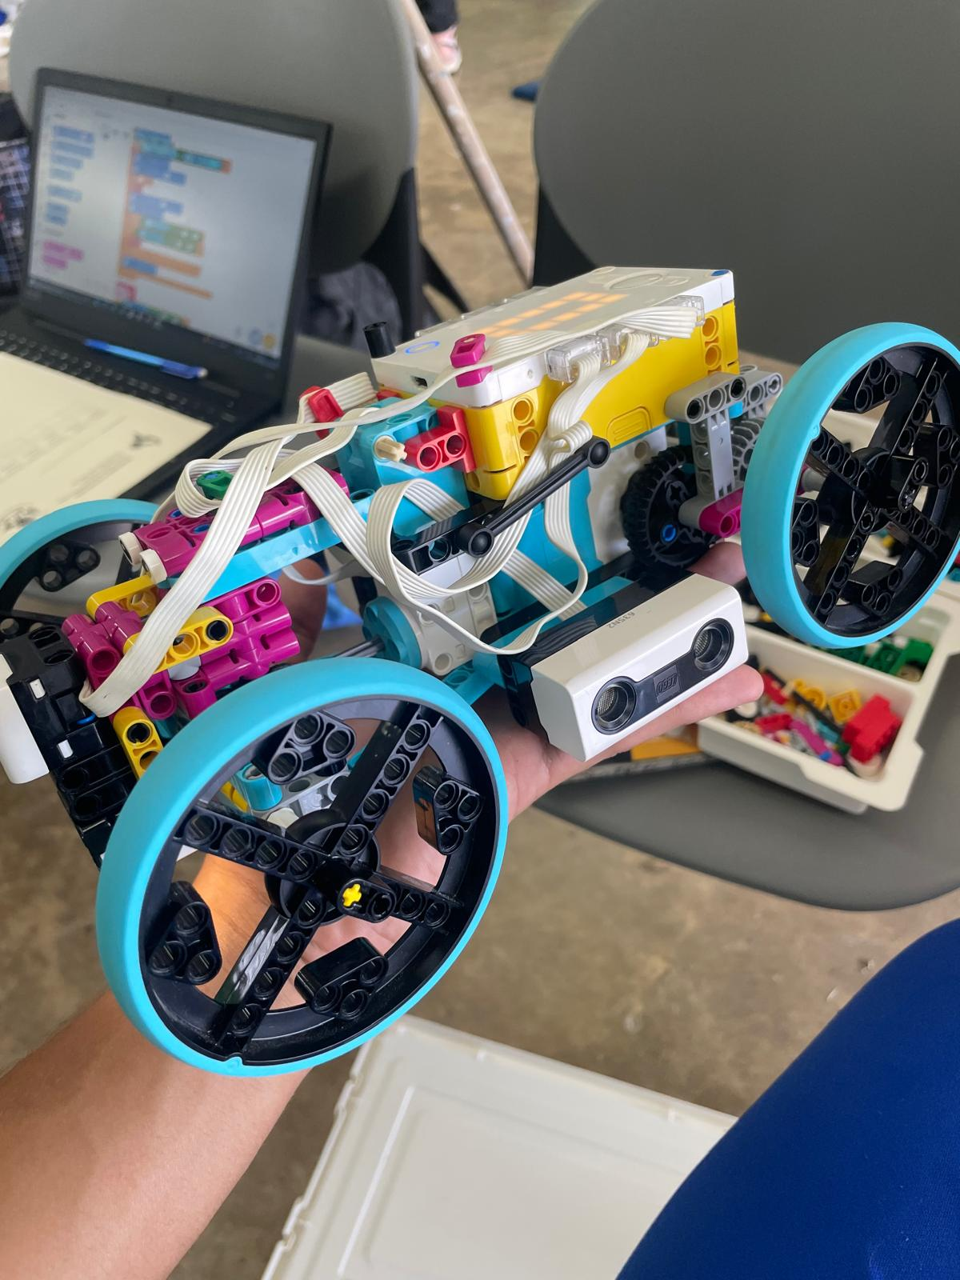CDC Model 04:

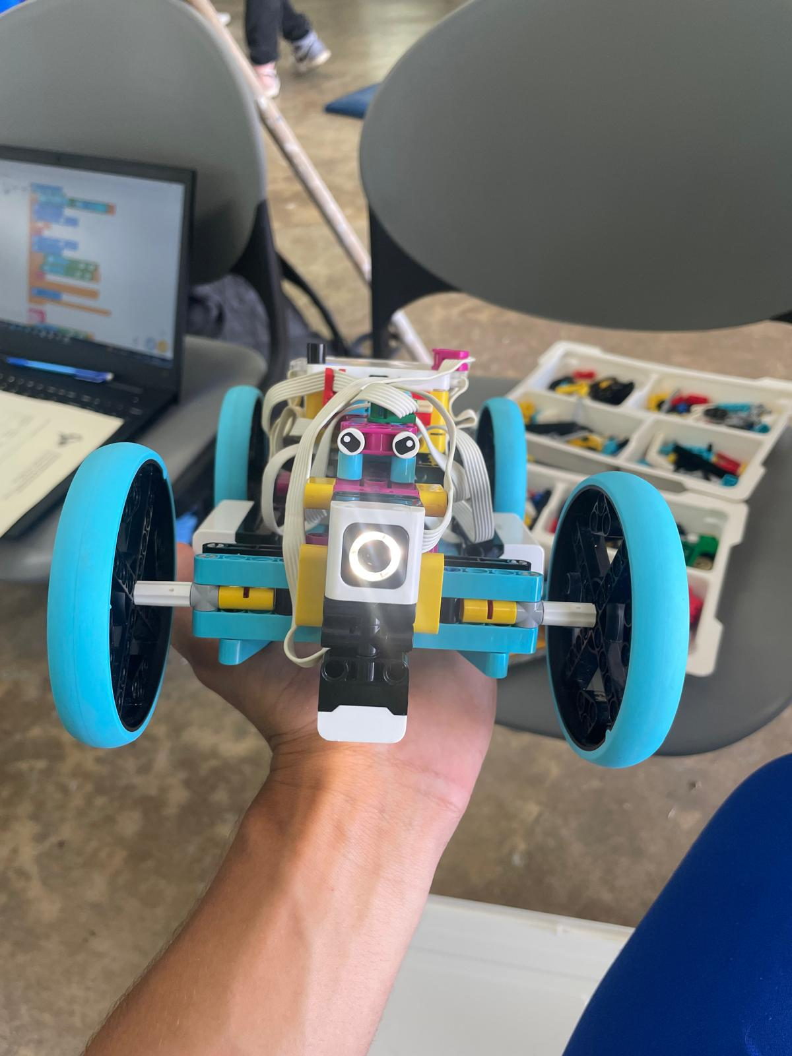

CDC Model 05:

CDC Model 06:

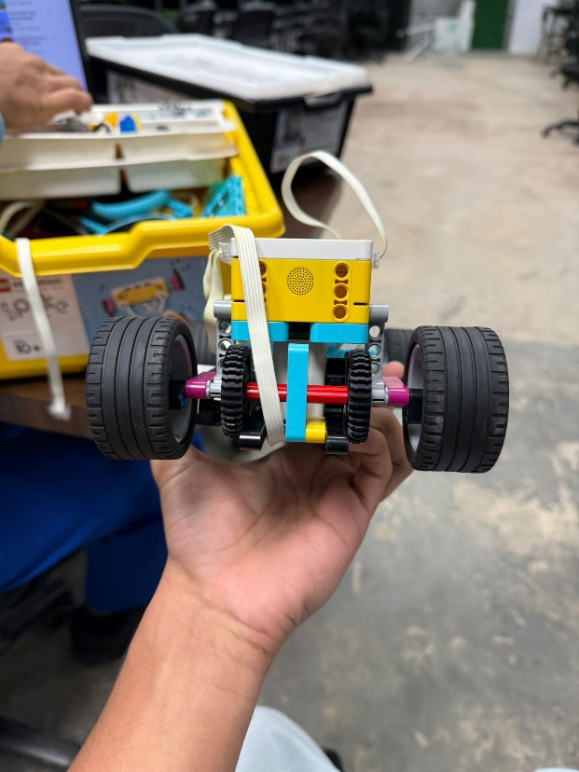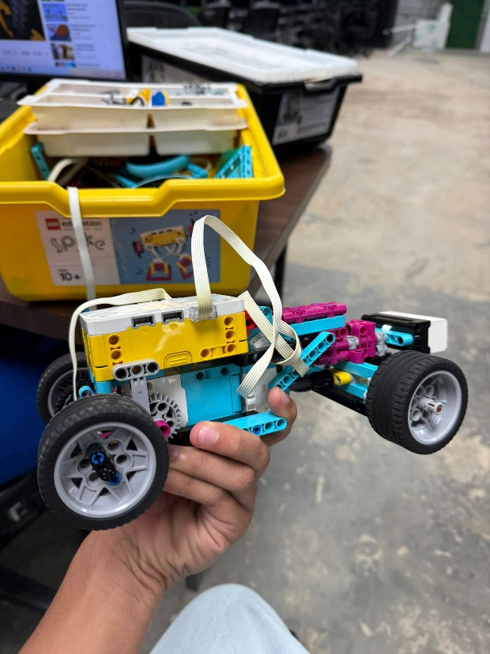

CDC Model 07:

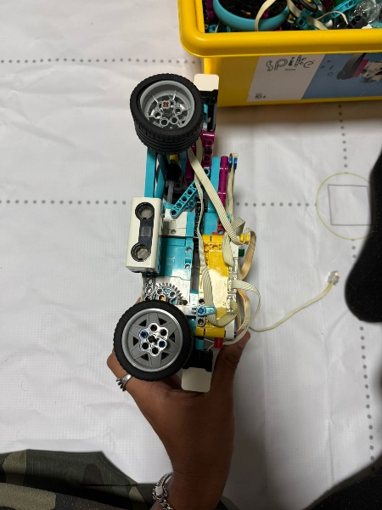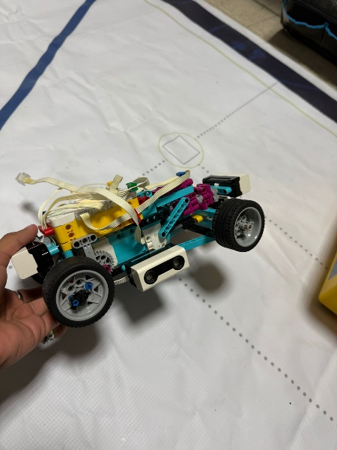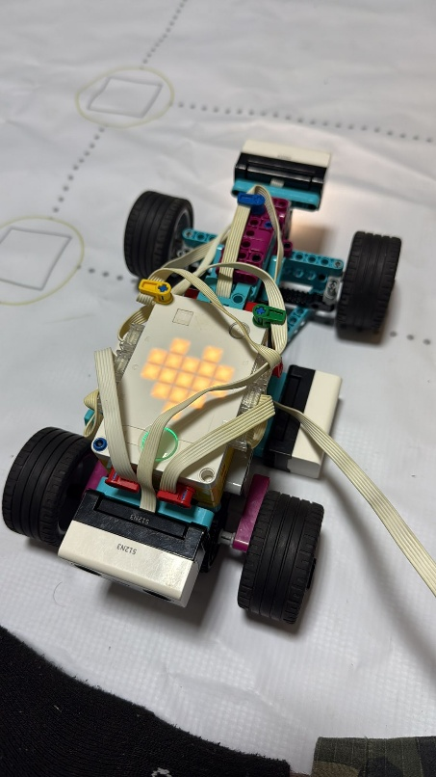

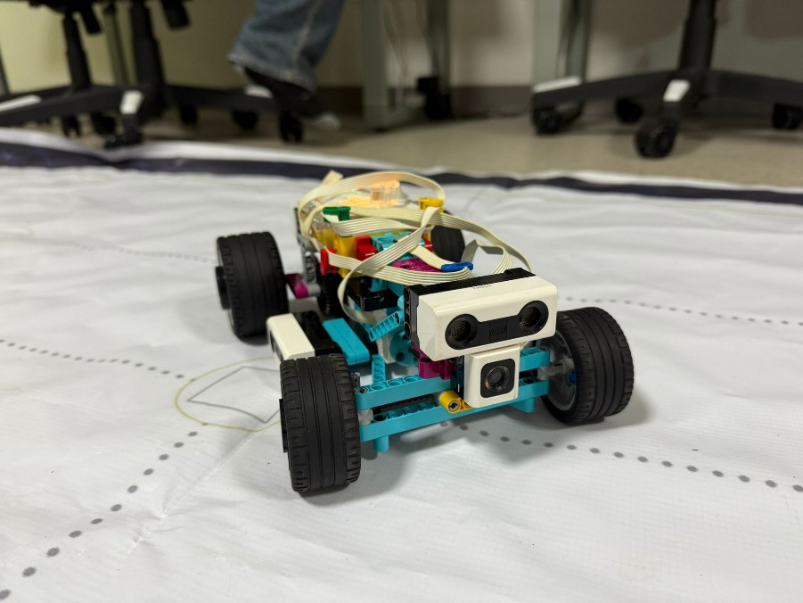

Team image:

